Week 3 Questions

- Pick a website built with Bootstrap. Have a play with different window sizes. Observe how the page responds and different elements wrap.
For a collection of websites built with Bootstrap, see http://expo.getbootstrap.com/

- Start a new project from scratch. Make sure you are familiar with the process, and you are able to set up a new project all by yourself.
Refer back to Hands-on Project 1 if you need assistance.

- Have you heard about jQuery? What is it? Look on the Internet to find out.
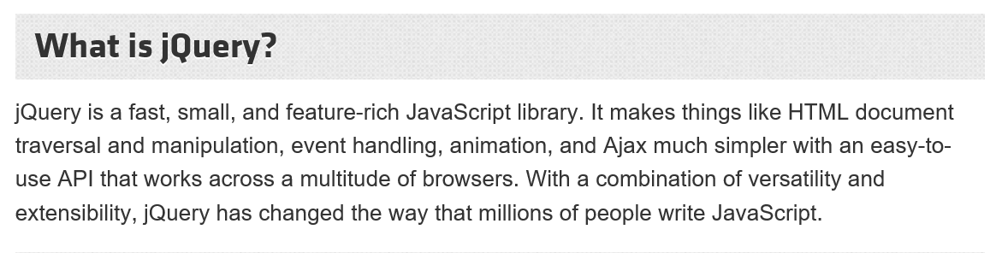
Basically, jQuery is built on top of JavaScript but is much simpler, more powerful and popular. If you want to be a web developer, put this on your list of ‘must-learn’ languages.

- Download the empty project shell from the unit website and investigate its folder structure and each line of the “index.html” file. Do you know what each line is doing? If not, do some research and find out.
Line 5-7: Defining meta-data
Line 5: Defining character set used
Line 6: Defining Microsoft browser compatibility
Line 7: Defining viewport, its width and initial scale
Lines 4,9 and 15 are comments (comments start with <!-- and end with -->
Line 10: Load jQuery library (without this, JavaScript components won’t work). Note that the name should match that found in the js folder.
Line 11: Load Bootstrap stylesheet. The name should match that found in the css folder.
Line 13: Load Bootstrap JS (without this, JavaScript components won’t work). The name should match that found in the js folder.

- Add some content to the page and make some customisations. For example, you could change the background colour, font colour, and/or font size (hint: you can do this with css styles)

- If you were to start your first web project, what would it be? Have a look at the Assignment 1 Specification and start thinking about what you want to produce.

- How solid is your HTML and CSS knowledge? Do you struggle to perform basic customisation on the page? If so, the following course is for you to check out after class.
Visit the following site and go through its tutorials. Make sure you are familiar with the content.
http://www.w3schools.com/html/default.asp
http://www.w3schools.com/css/css3_intro.asp

- Readings
  - Top 5 CSS Frameworks for Developers and Designers (https://www.browserstack.com/guide/top-css-frameworks )
  - BootStrap (front-end framework)
(https://en.wikipedia.org/wiki/Bootstrap_(front-end_framework)

(Last update: 15 Feb. 2022)

